Bus Reservation System

# Table of Contents

1. Project Overview  
2. Technology Stack  
3. Features  
4. Architecture Diagram  
5. Database Design  
6. Modules and Pages  
7. Security  
8. Dependencies  
9. Screenshots  
10. How to Run  
11. Future Improvements

# Project Overview

The Bus Reservation System is a web application that allows users to register, login, view available trips, book seats, and manage bookings. Admins can manage buses, trips, and users.

# Technology Stack

- Backend: Spring Boot (Java)  
- Frontend: Thymeleaf, HTML, CSS  
- Database: MongoDB  
- Security: Spring Security  
- Build Tool: Maven

# Features

**User:**  
 - Register & Login  
 - View trips  
 - Book trips  
 - View & cancel bookings

**Admin**:  
 - Manage buses (add/update/list)  
 - Manage trips  
 - View all users & bookings

**Architecture Diagram**

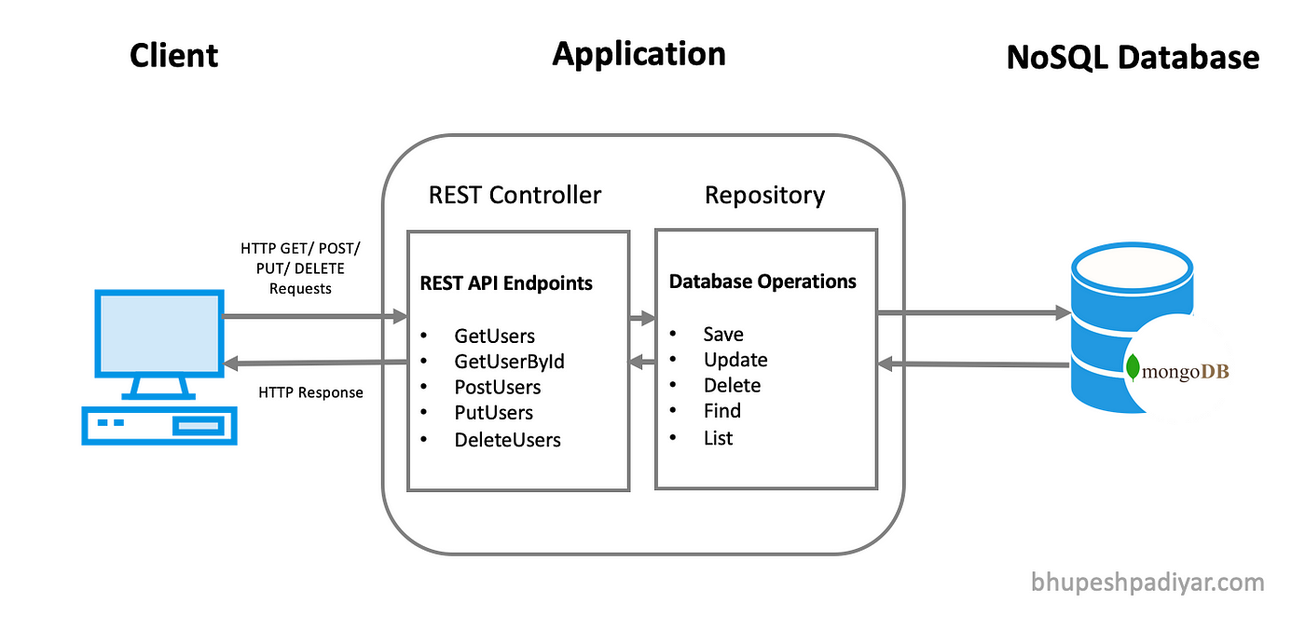

# Database Design

**Models and Relationships:**  
  
 - User: has fields: username, password, age, gender, address, roles, @DBRef: Bus  
 - Bus: fields: number, type, capacity  
 - Trip: @DBRef: user, list of users  
 - Booking: @DBRef: Trip

# Modules and Pages

- Home: / (Public)  
 - Login: /login (Public)  
 - Register: /users/register (Public)  
 - Add Bus: /buses/add (Admin)  
 - List Buses: /buses/list (Admin)  
 - Add Trip: /trips/add (Admin)  
 - List Trips: /trips/list (Admin/User)  
 - Book Trip: /bookings/new (User)  
 - View Bookings: /bookings/list (Admin)

# Security

- Custom UserDetailsService integrated with MongoDB  
 - Password encryption with BCrypt  
 - Role-based access (ADMIN, USER)  
 - Public access to login, register, CSS

# Dependencies (pom.xml)

<dependencies>  
 <dependency>spring-boot-starter-thymeleaf</dependency>  
 <dependency>spring-boot-starter-web</dependency>  
 <dependency>spring-boot-starter-data-mongodb</dependency>  
 <dependency>spring-boot-starter-security</dependency>  
 <dependency>spring-boot-devtools</dependency>  
 <dependency>spring-boot-starter-test</dependency>  
 </dependencies>

# Screenshots (Optional)

**Properties:-**

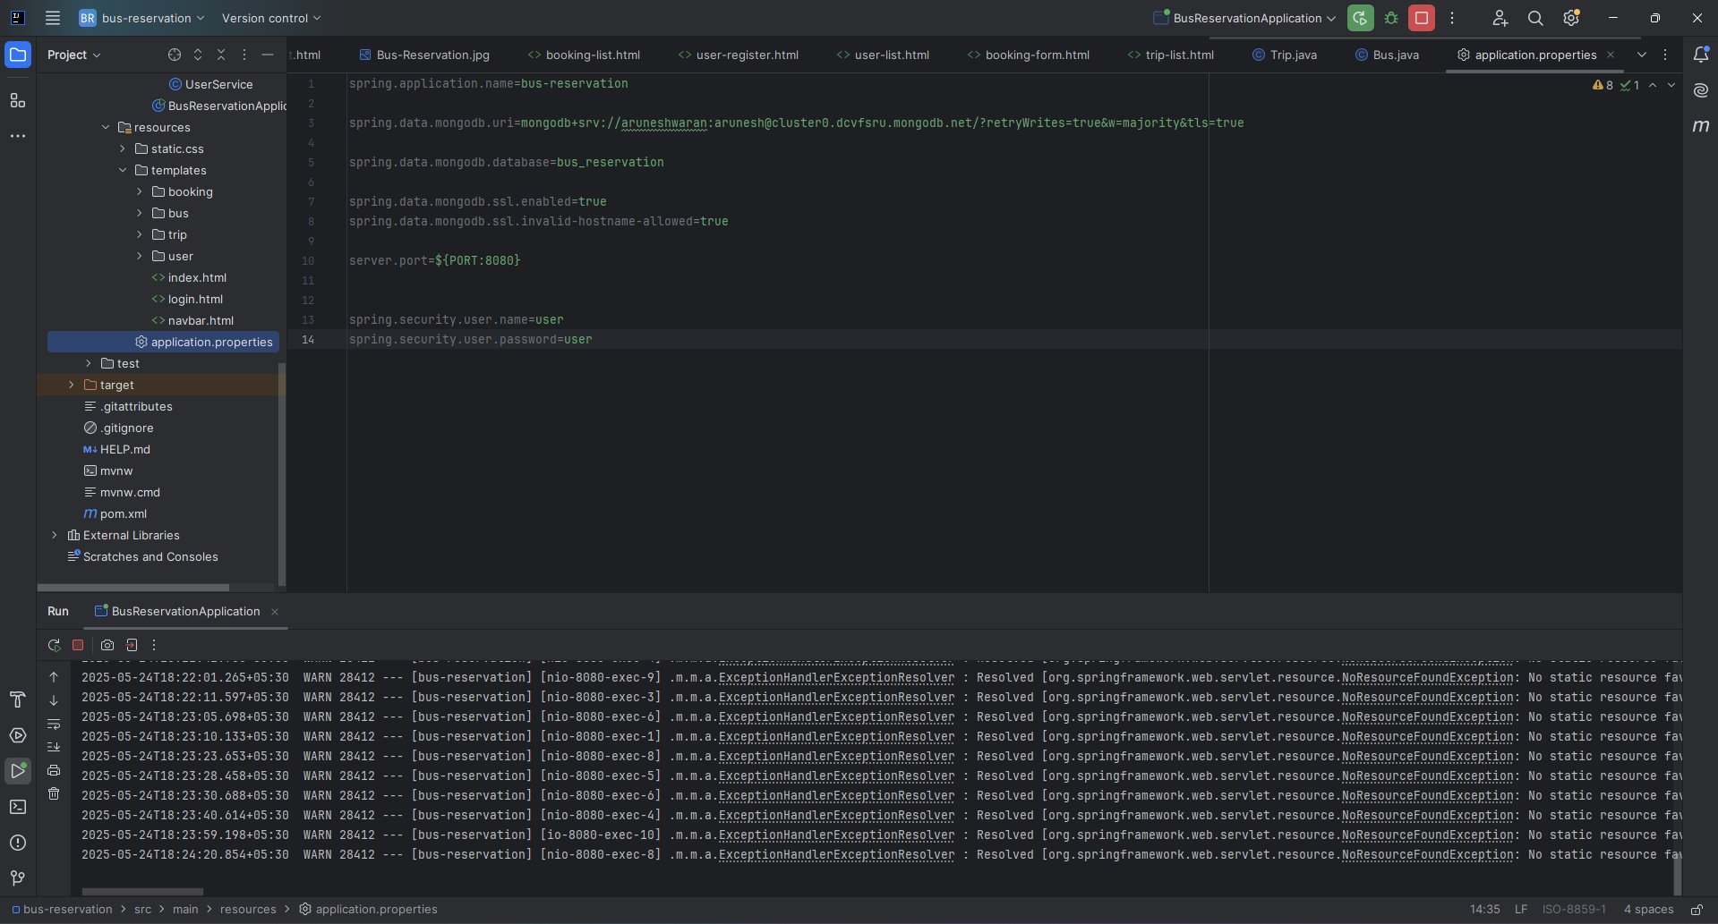

**Model Layer:-**

**User model:**

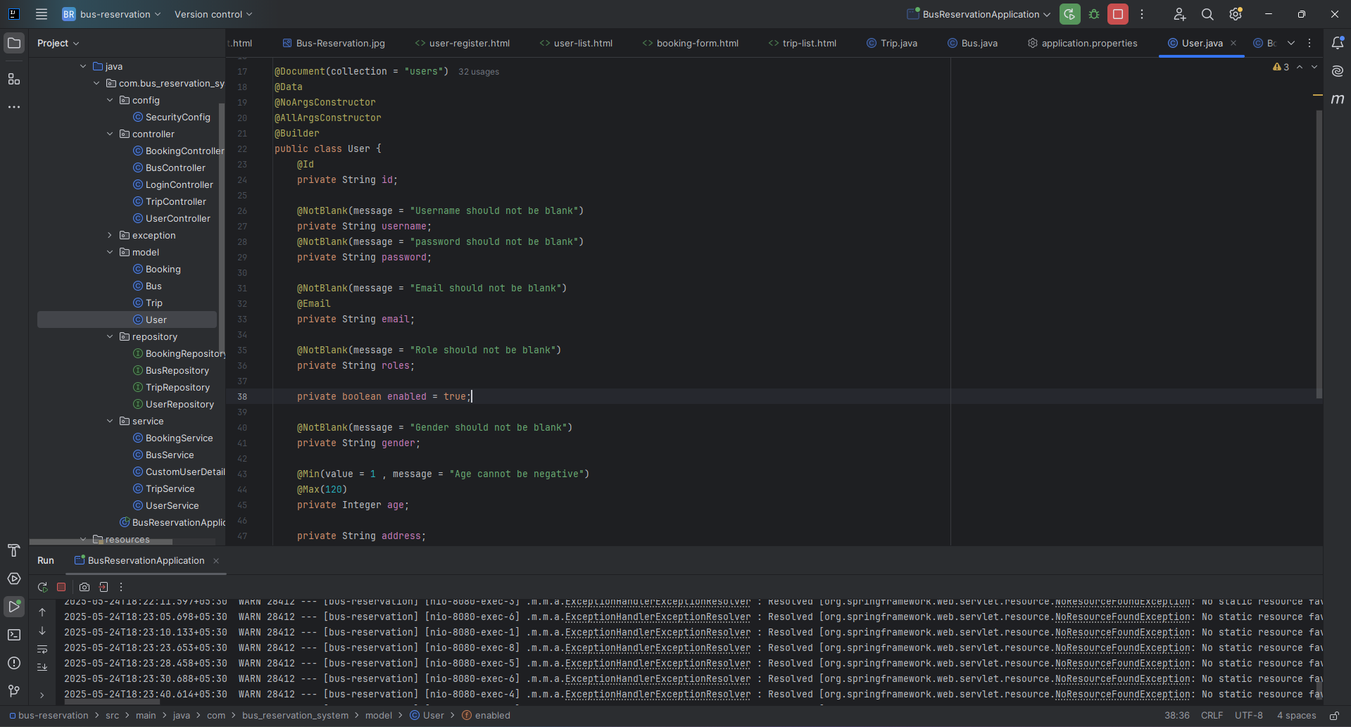

**Trip model:**

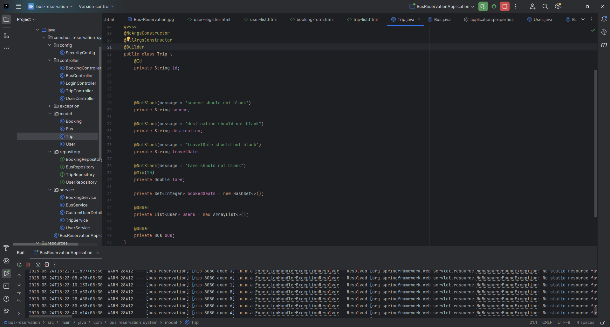

**Bus model:**

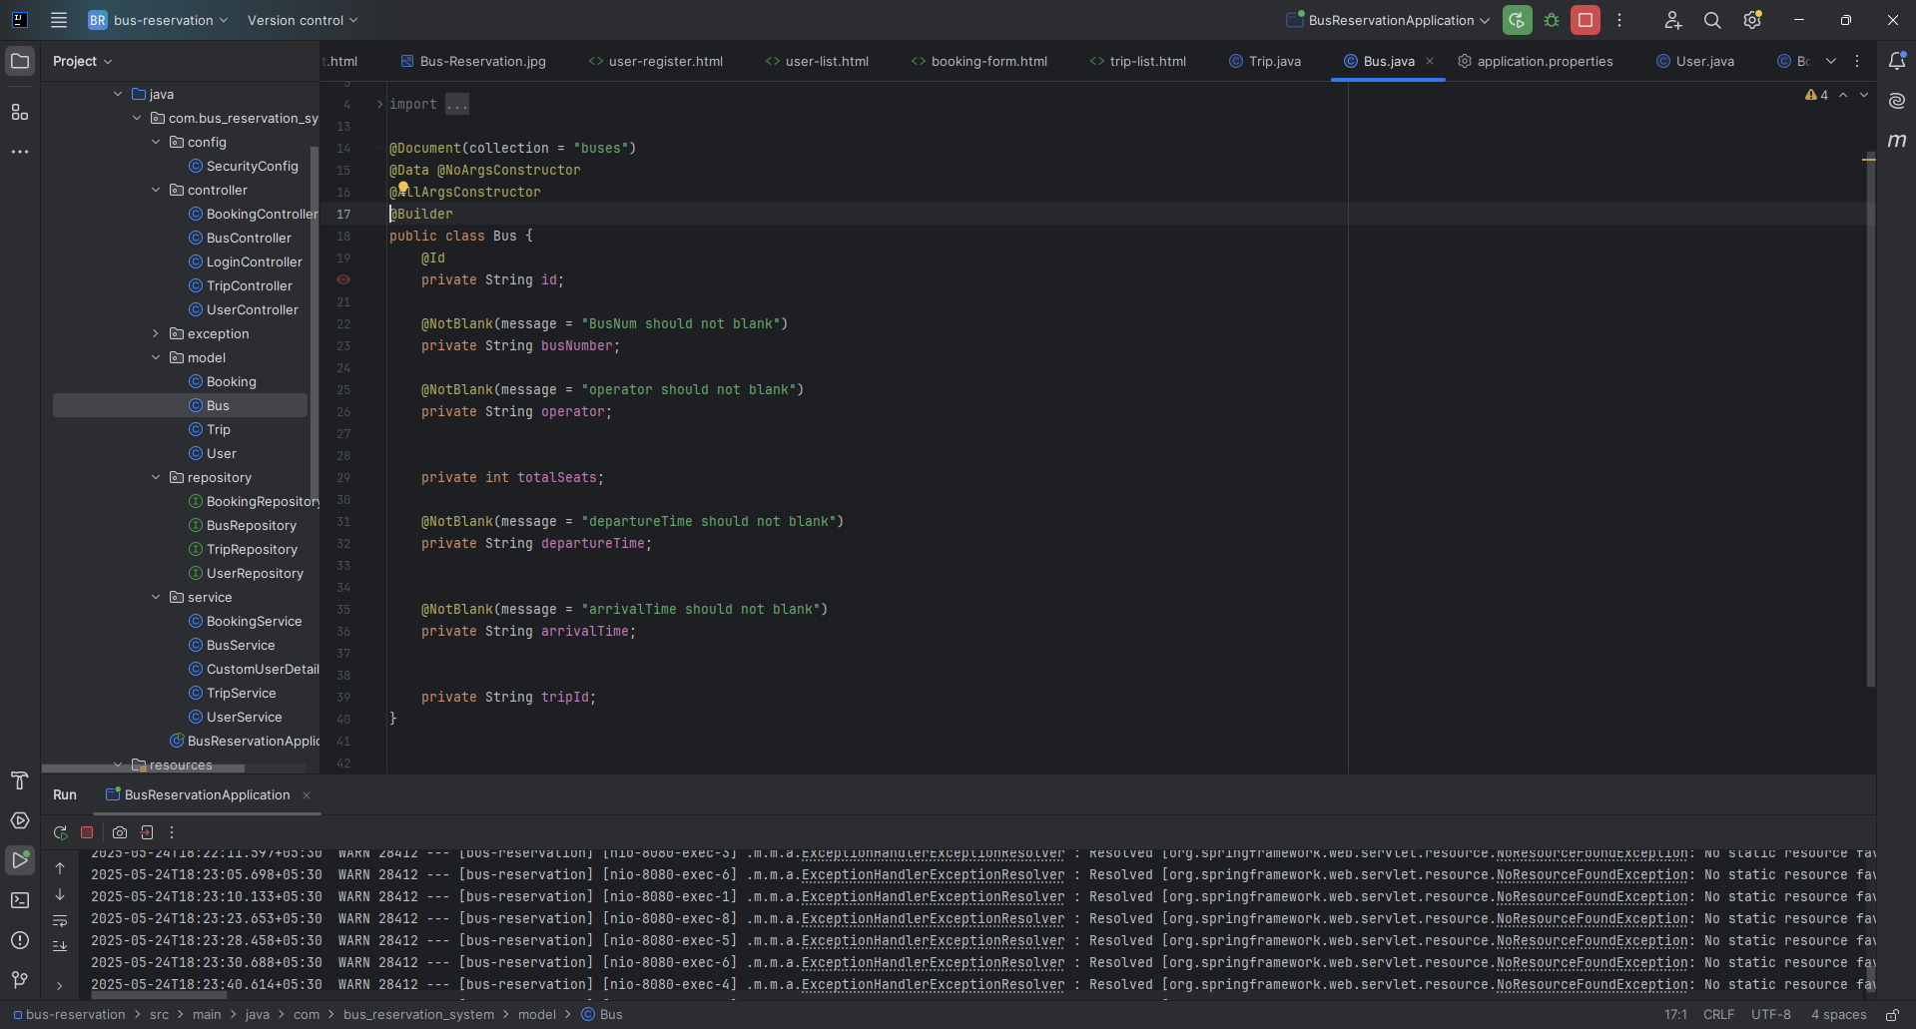

**Booking model:**

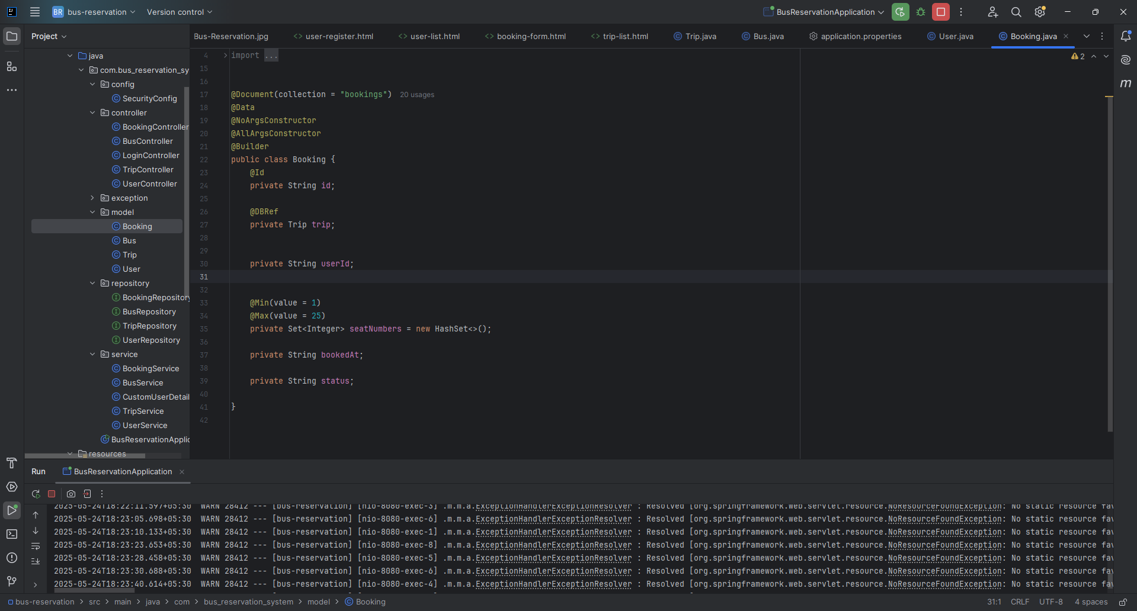

**Repository Layer:-**

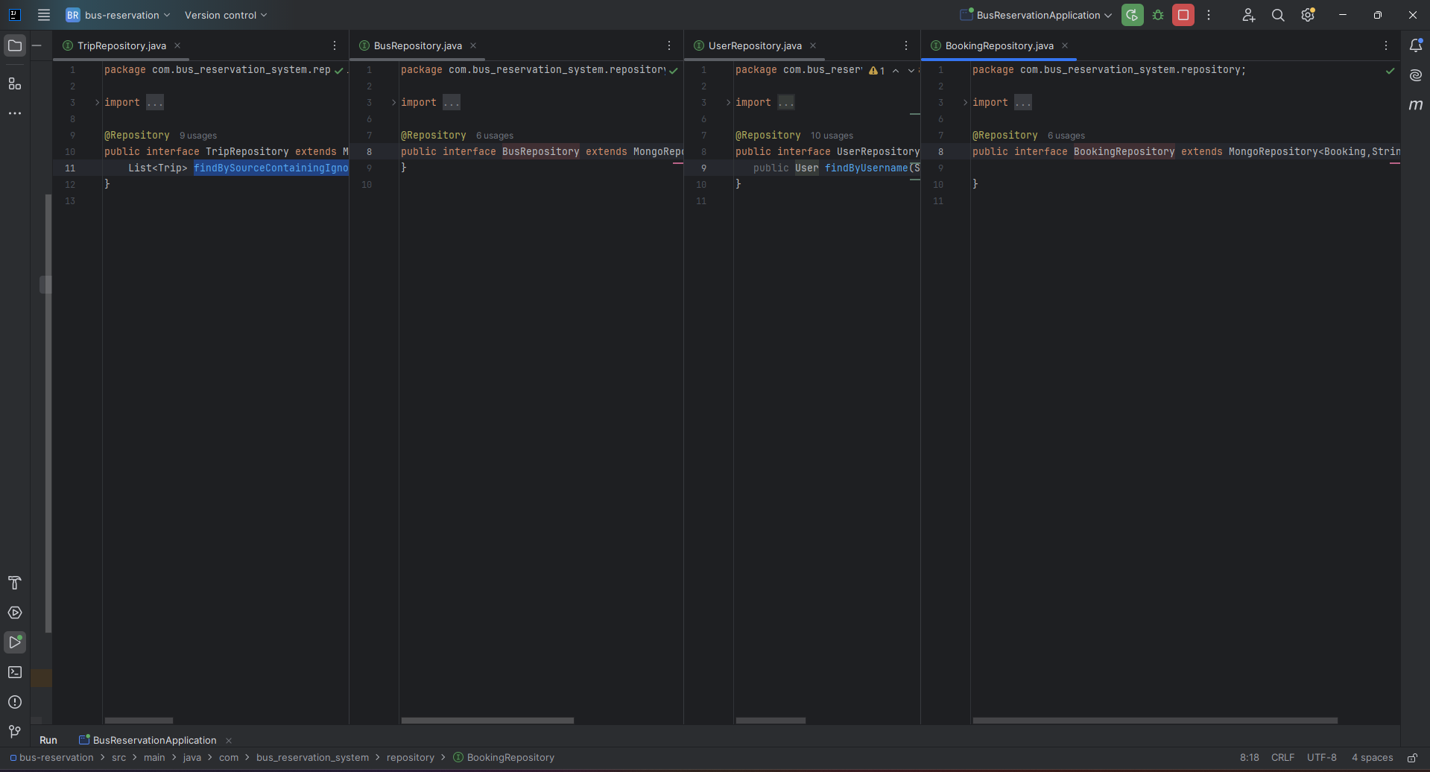

**Service Layer:-**

**User service:**

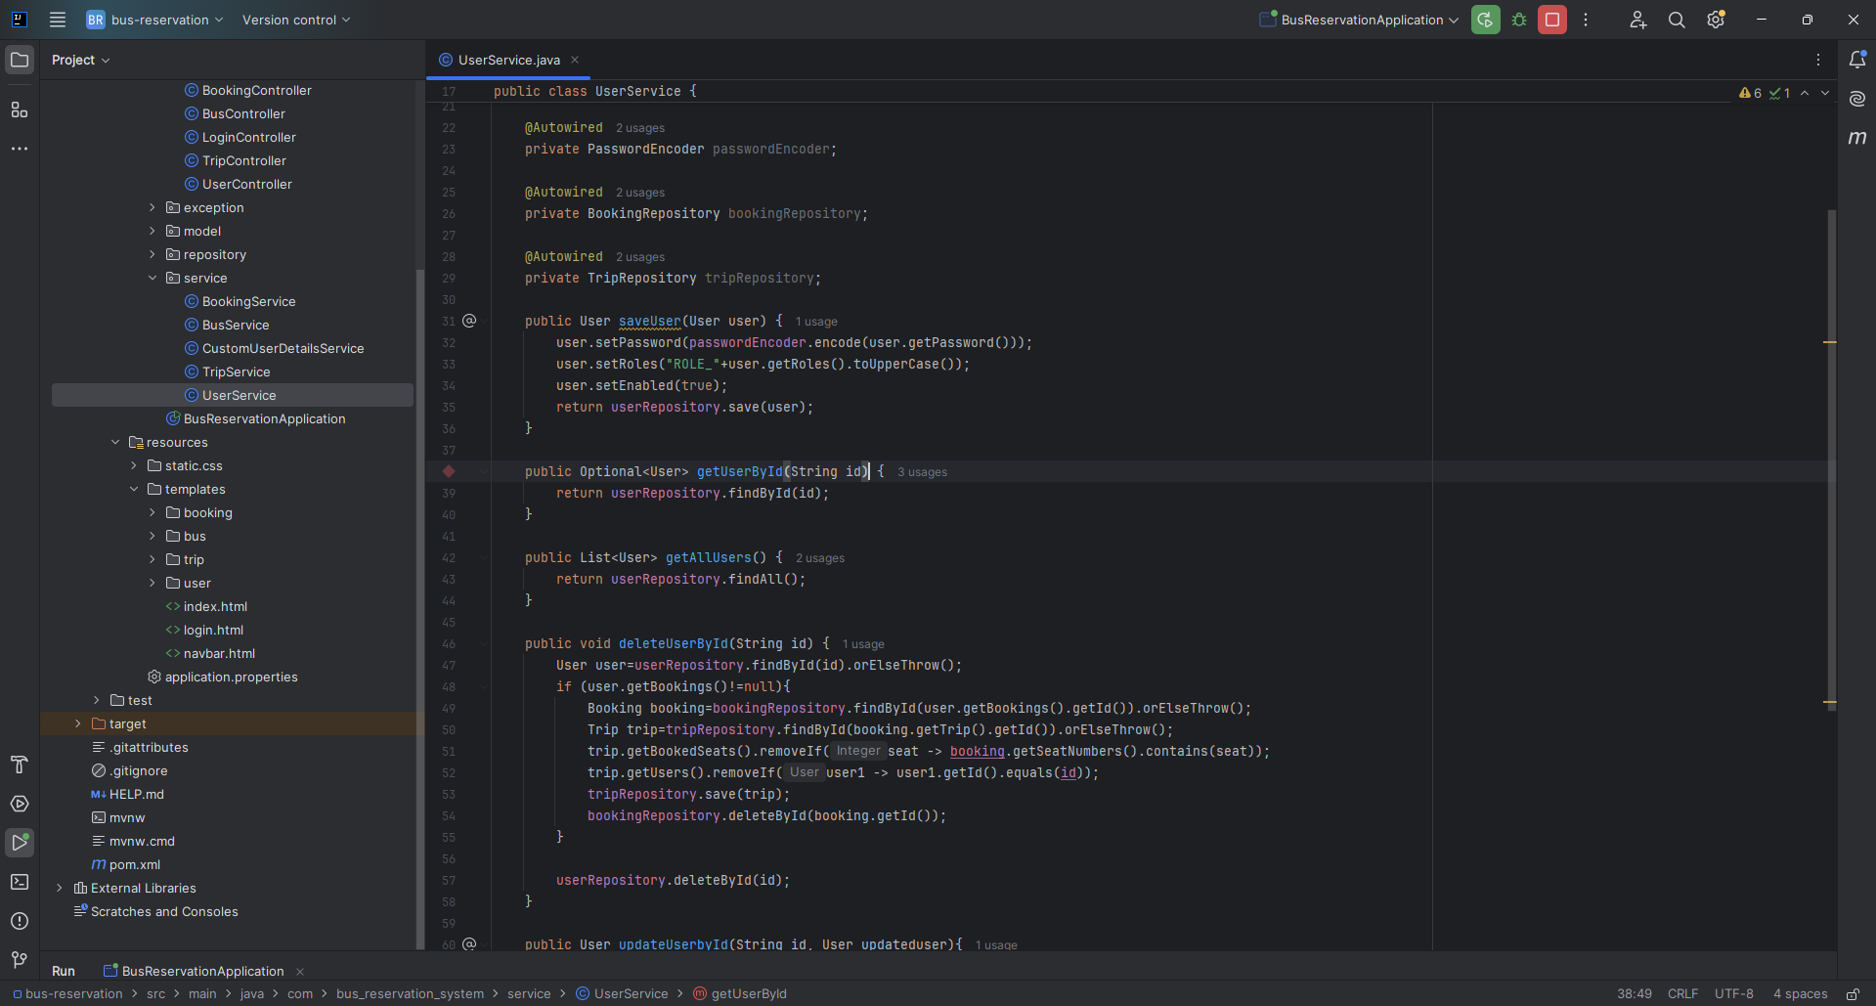

**Trip service:**

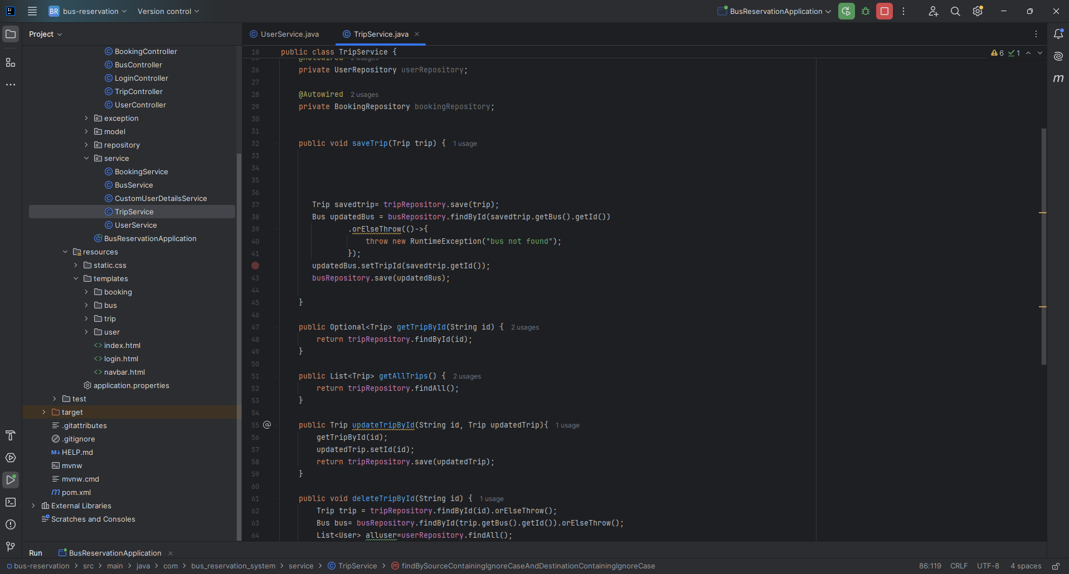

**Bus service:**

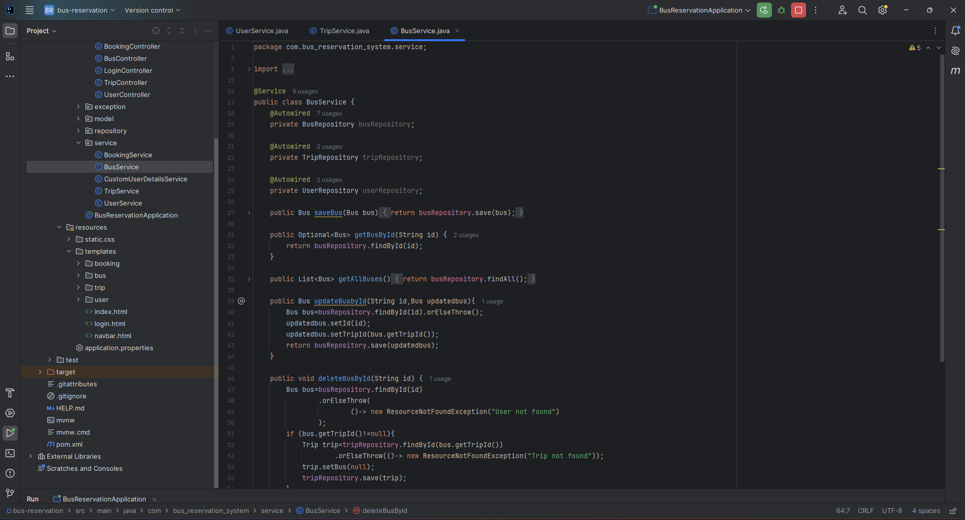

**Booking service:**

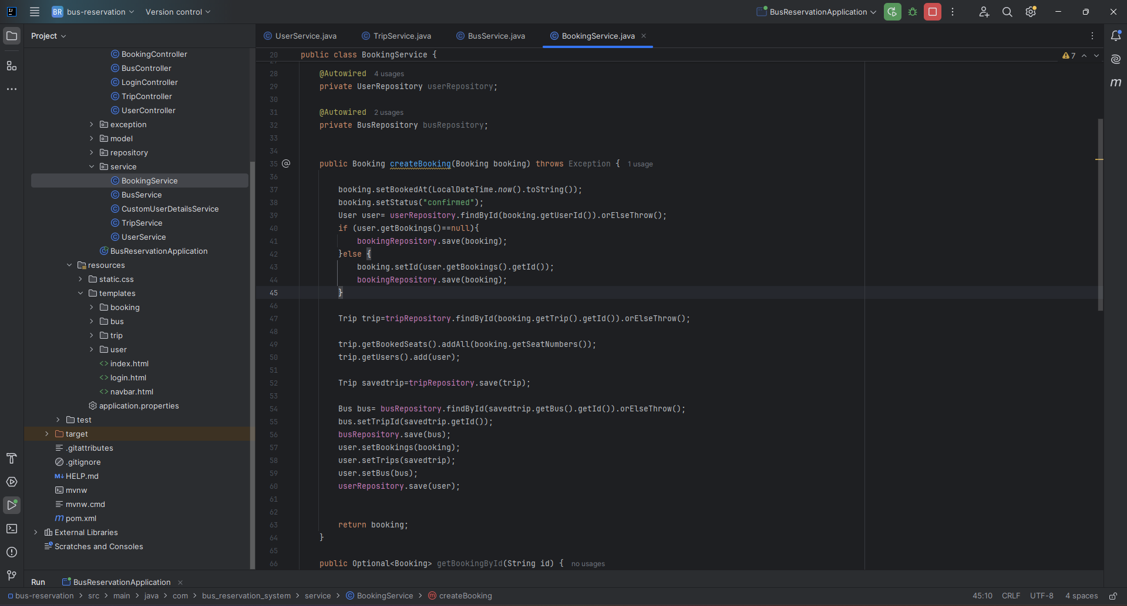

**Custom User Detail service:**

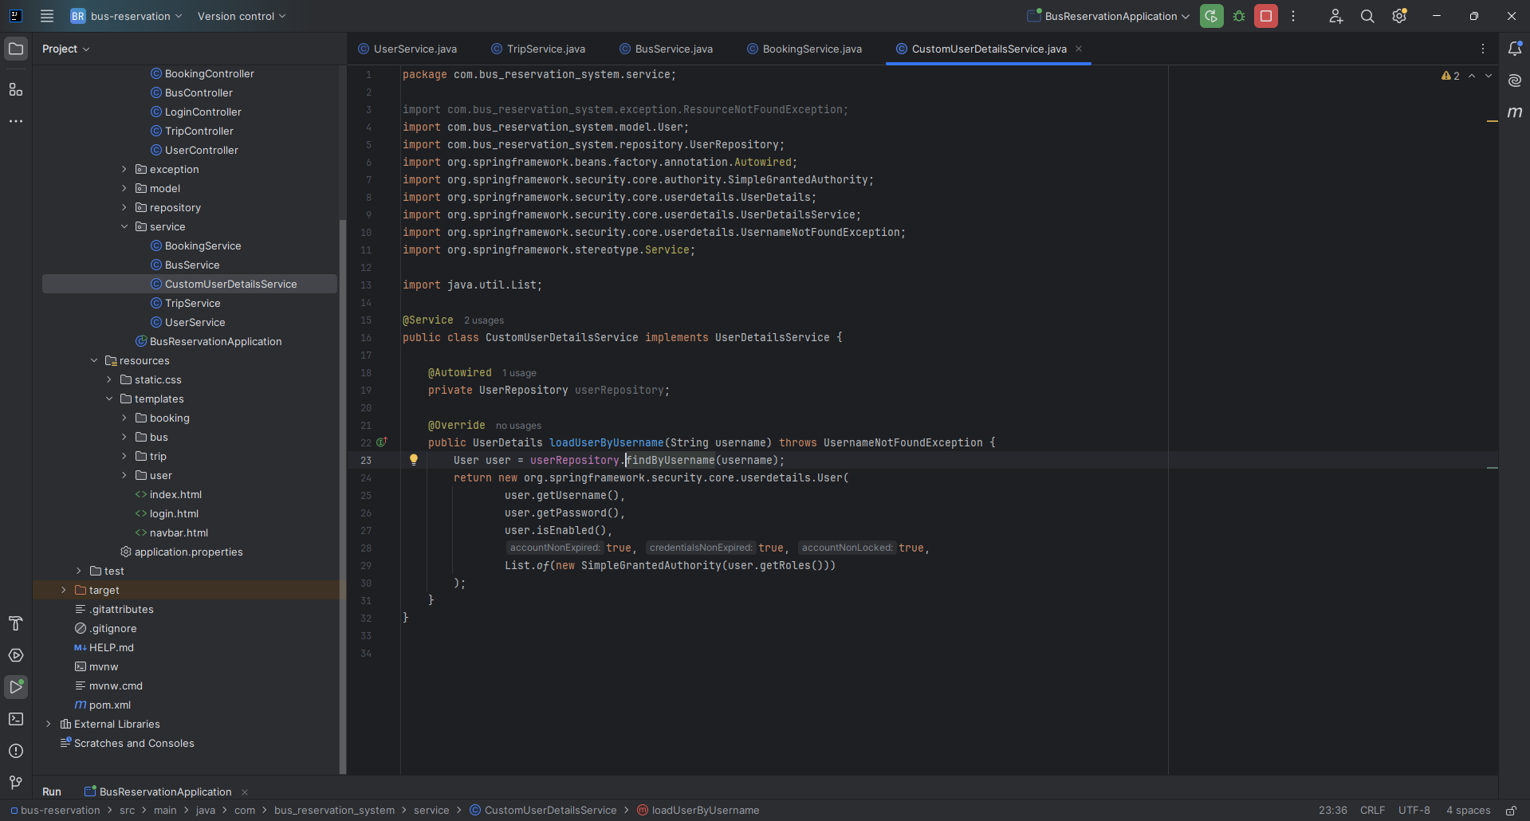

**Controller Layer:**

**User controller:**

# 

**Trip controller:**

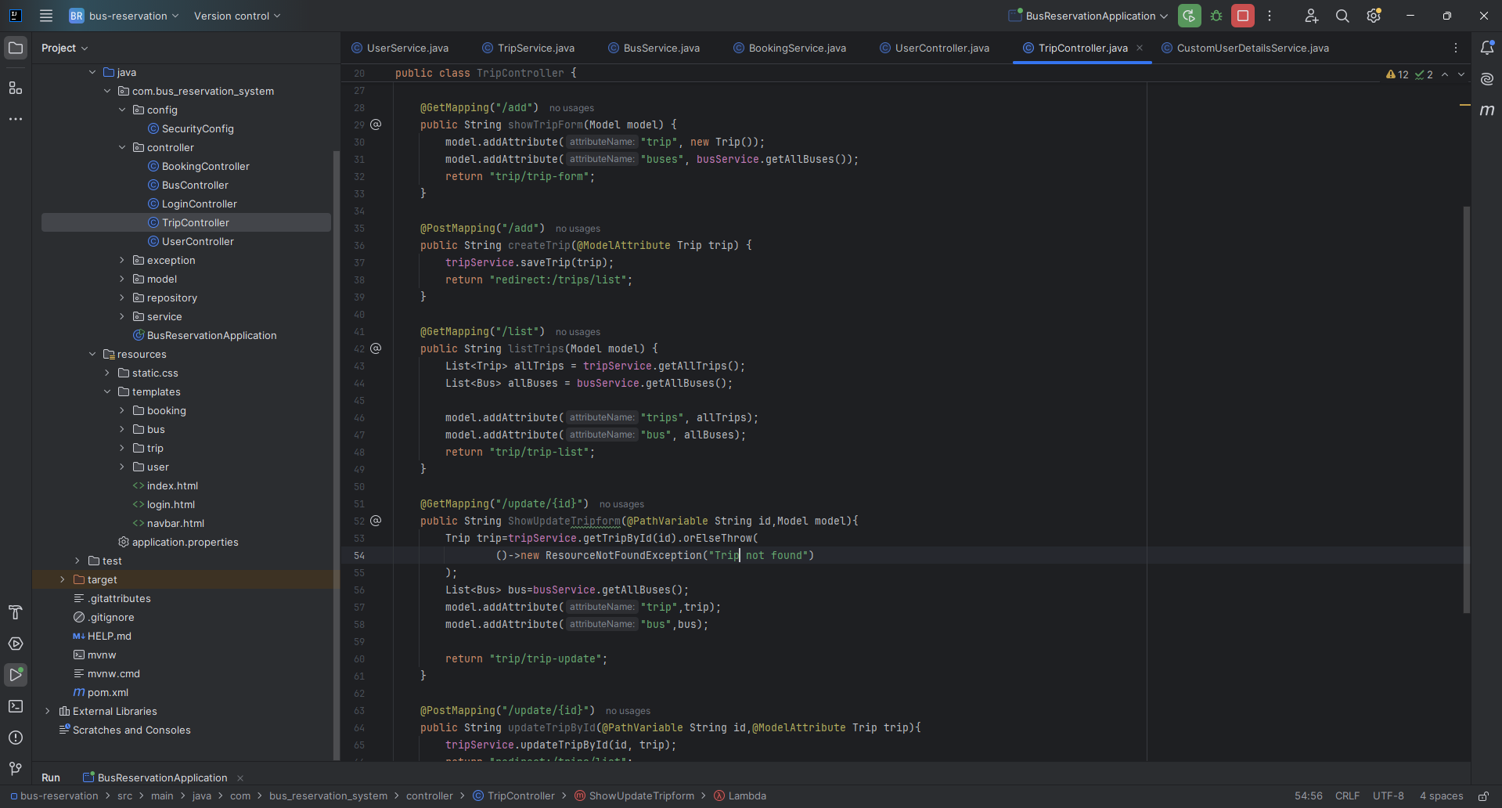

**Bus controller:**

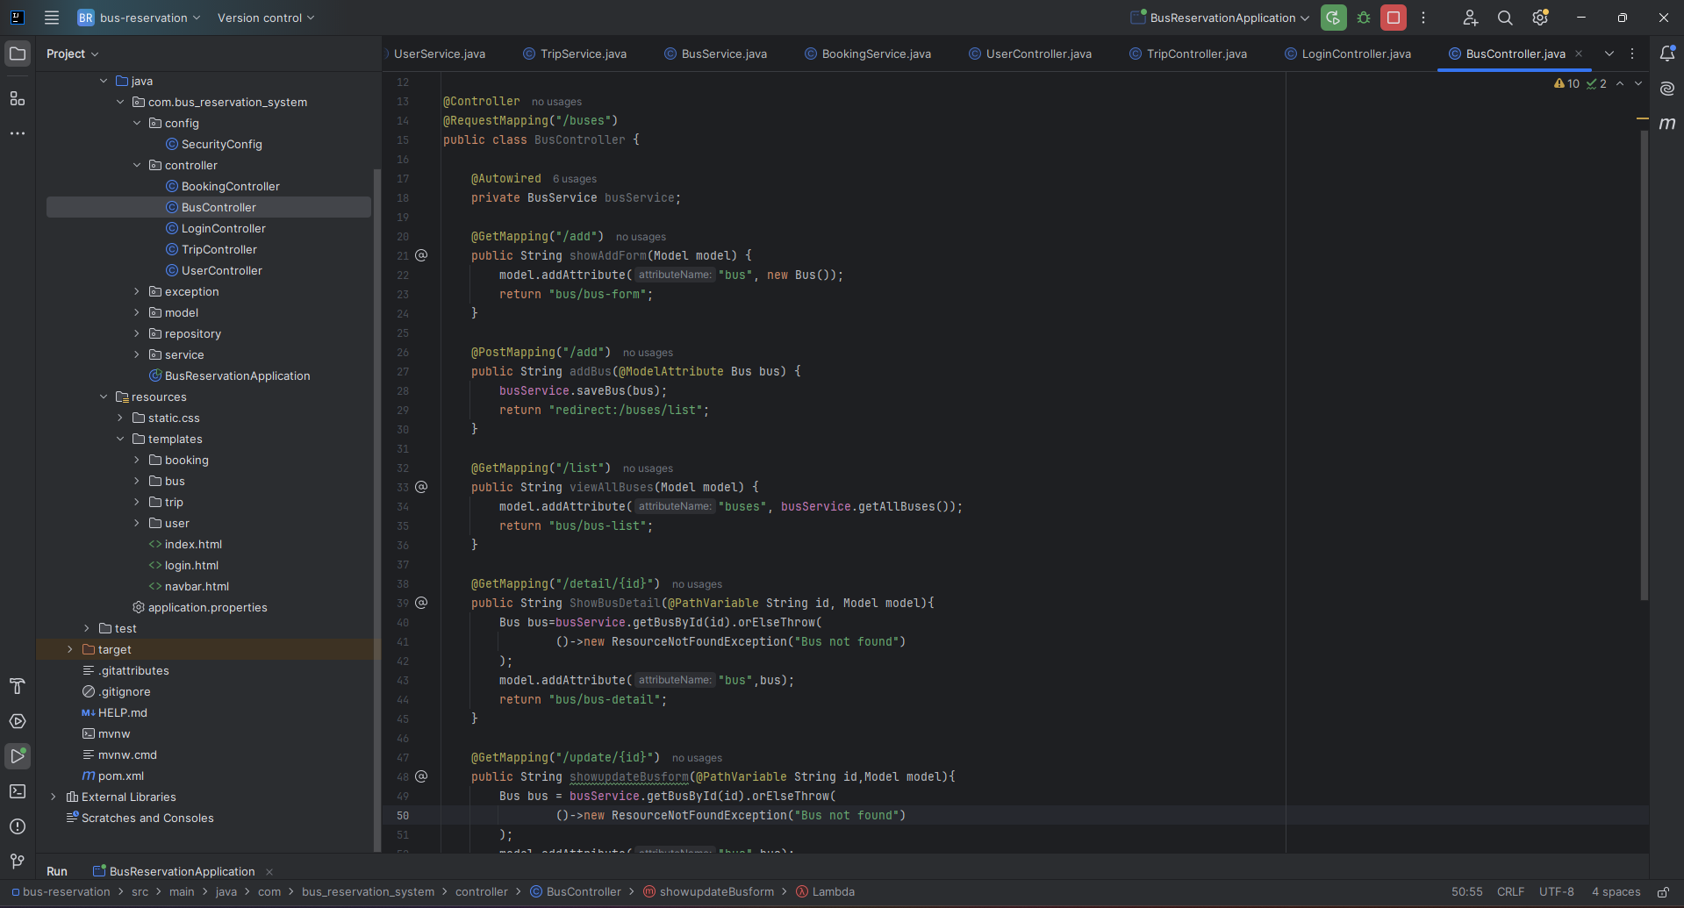

**Booking controller:**

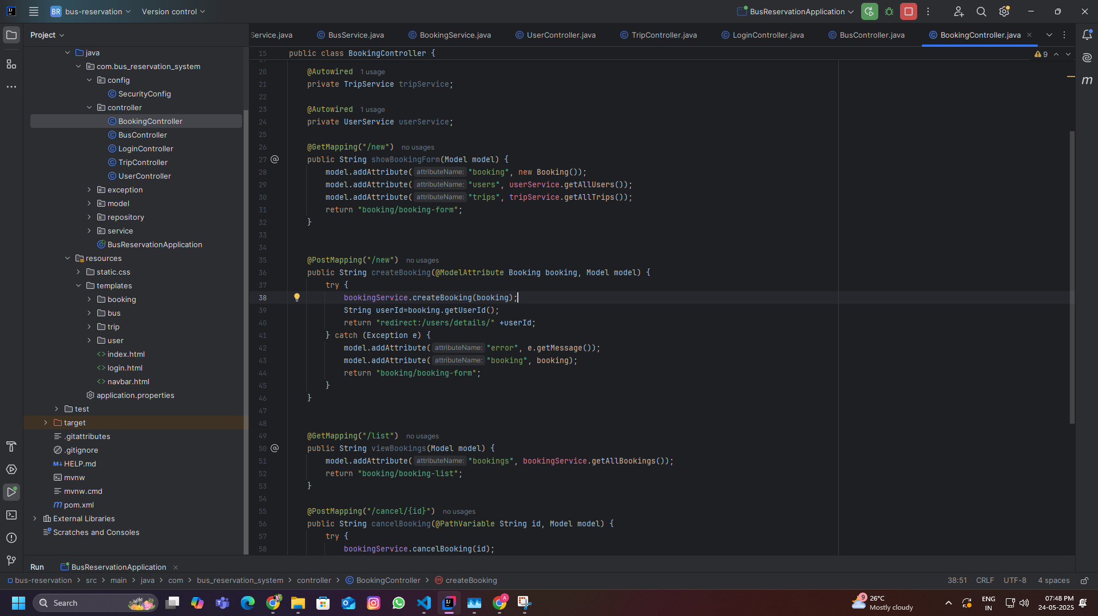

**Login controller:**

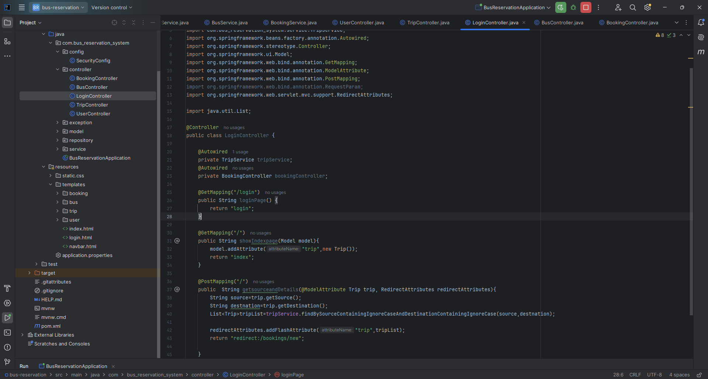

**Config Layer:-**

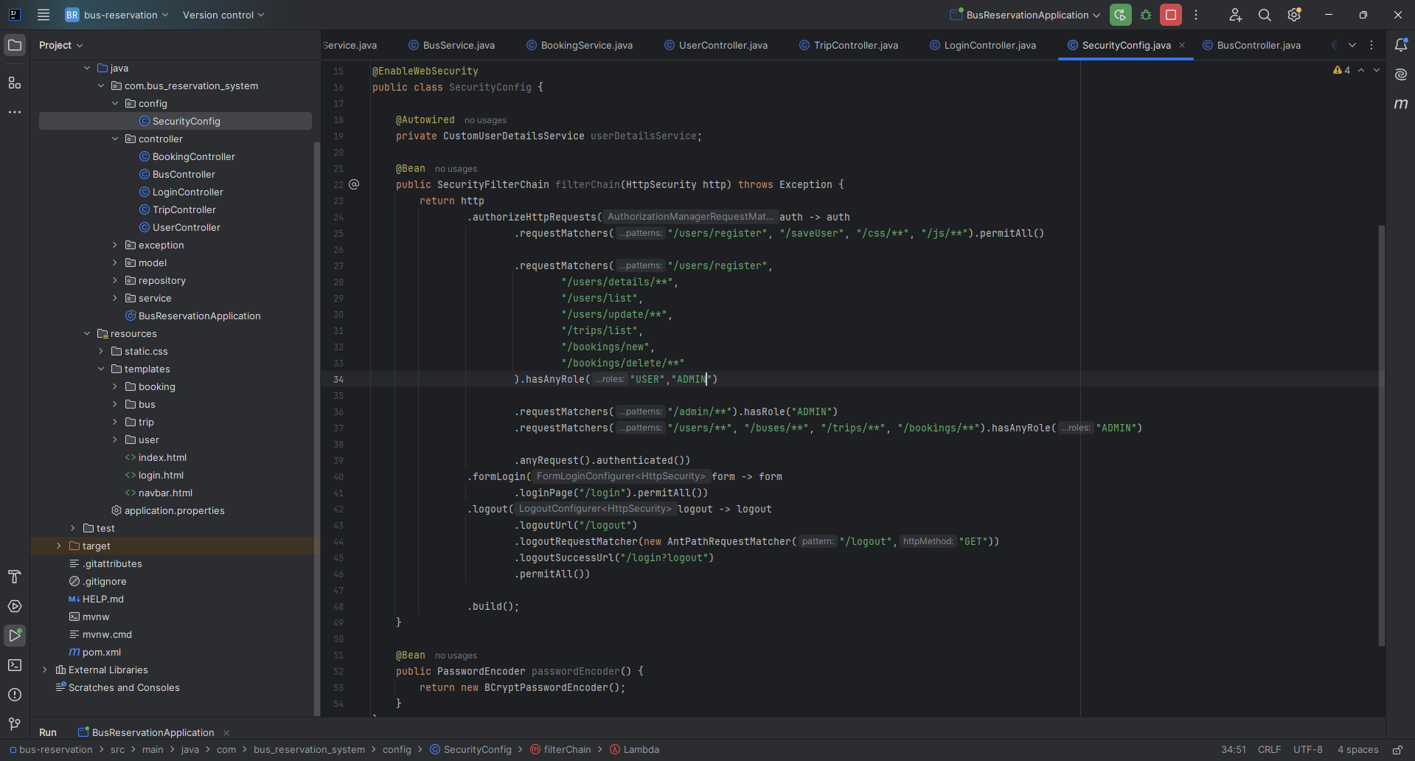

**Database:**

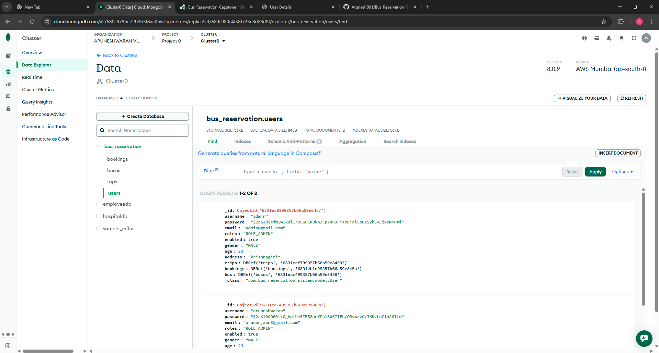

**Outputs:-**

**Endpoint “login”:**

[**https://bus-reservation-capstone.onrender.com/login?logout**](https://bus-reservation-capstone.onrender.com/login?logout)

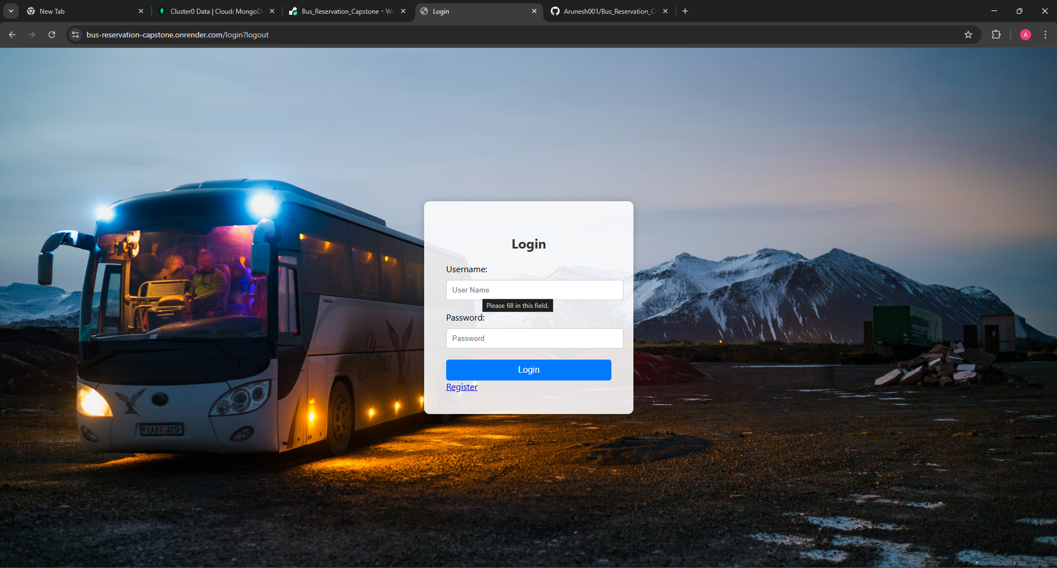

**Endpoint “/”:**

[**https://bus-reservation-capstone.onrender.com/?continue**](https://bus-reservation-capstone.onrender.com/?continue)

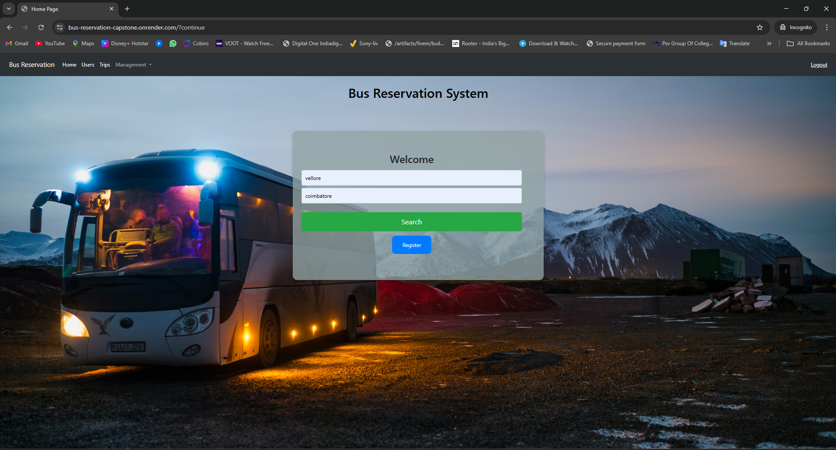

**Endpoint “/users/list”:**

**https://bus-reservation-capstone.onrender.com/users/list**

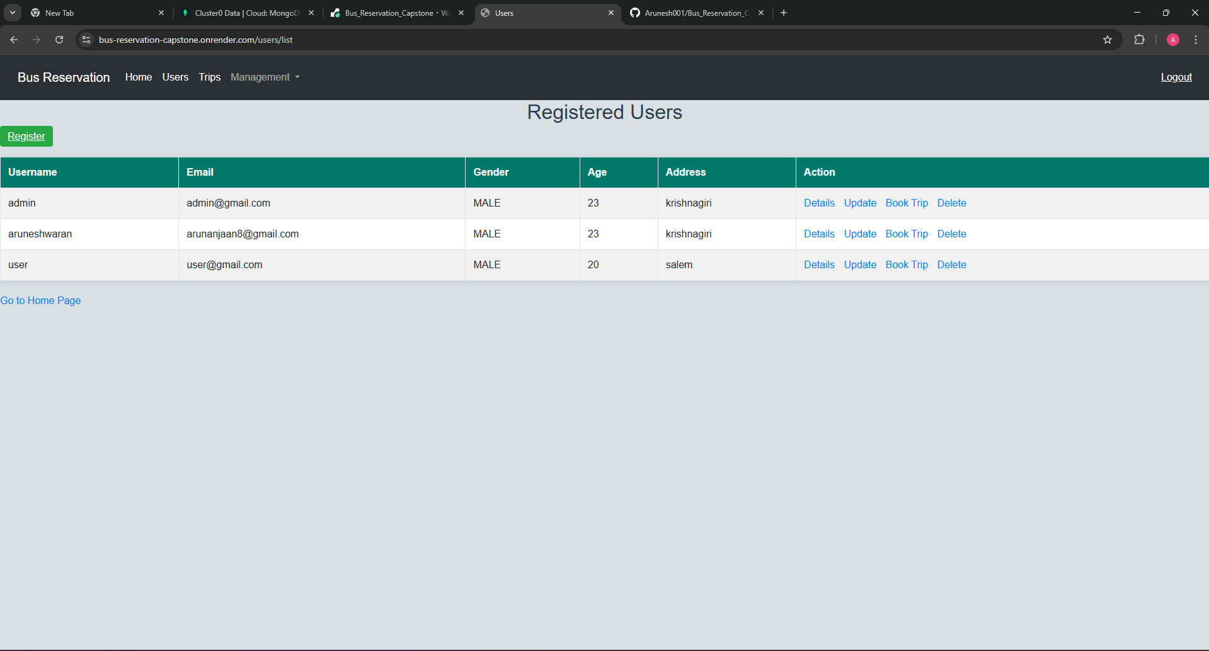

**Endpoint “/users/register”:**

**https://bus-reservation-capstone.onrender.com/users/register**

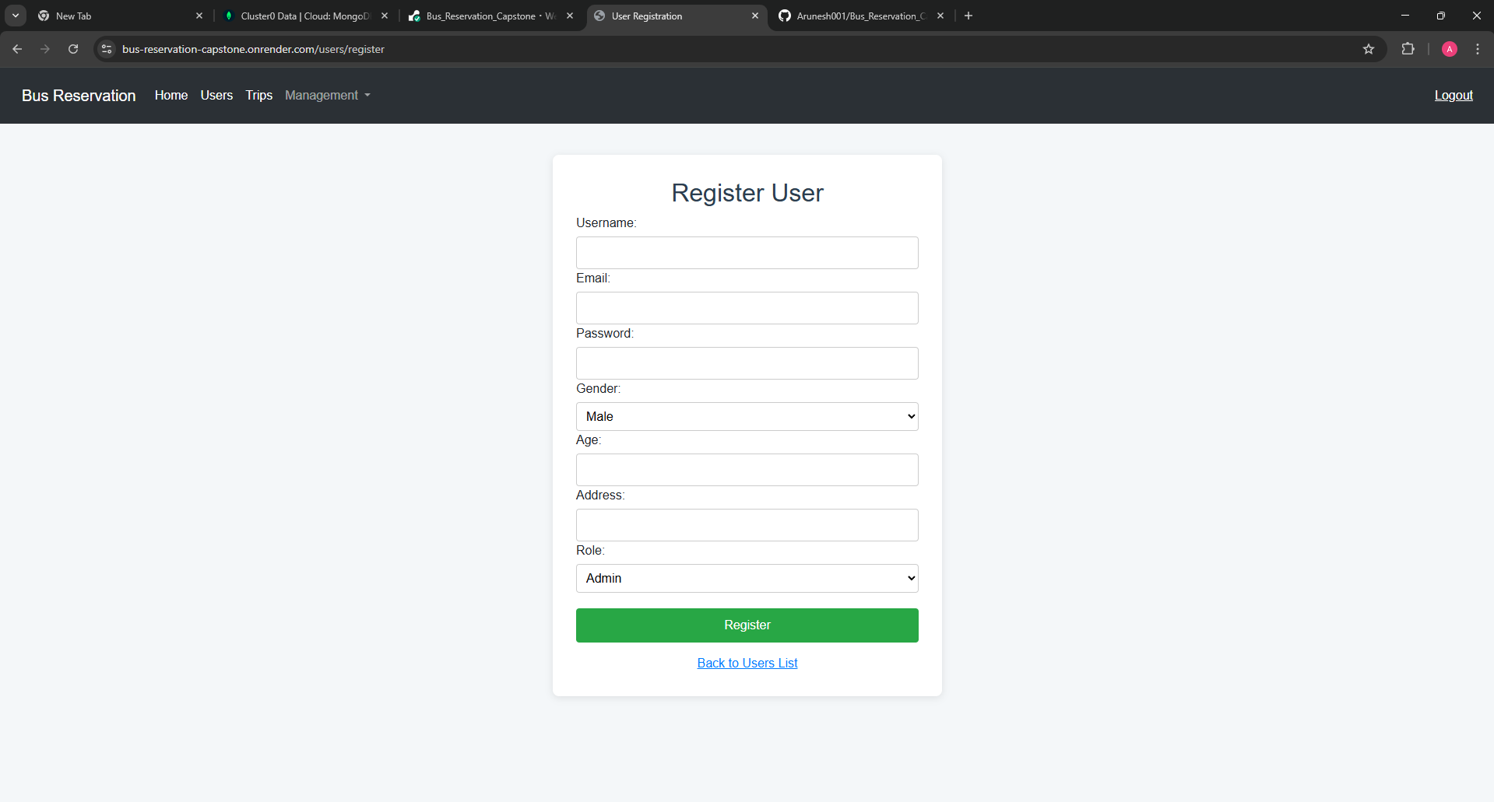

**Endpoint “/users/details/{id}”:**

**https://bus-reservation-capstone.onrender.com/users/details/6831ec7499357b66a59e845b**

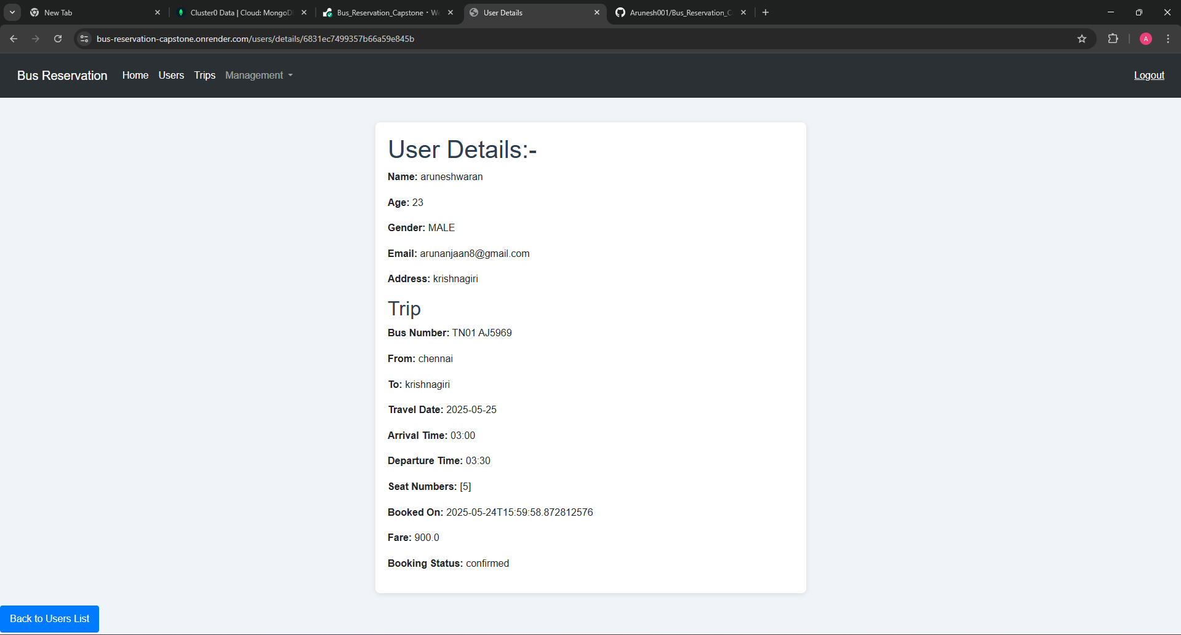

**Endpoint “/users/update/{id}”:**

**https://bus-reservation-capstone.onrender.com/users/update/6831ec7499357b66a59e845b**

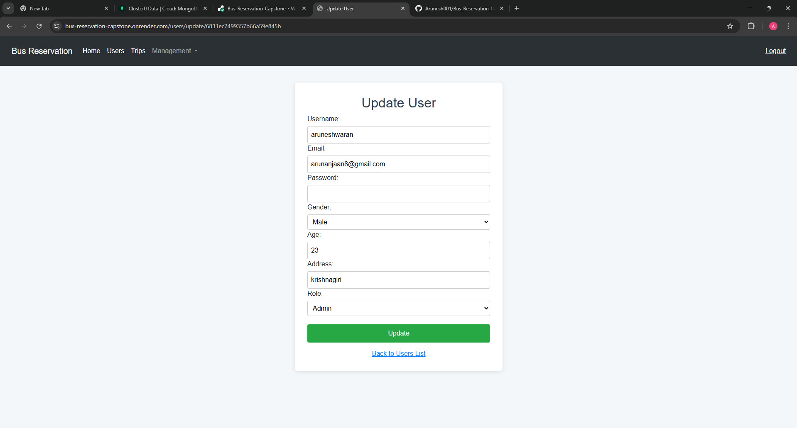

**Endpoint “/trips/add”:**

**https://bus-reservation-capstone.onrender.com/trips/add**

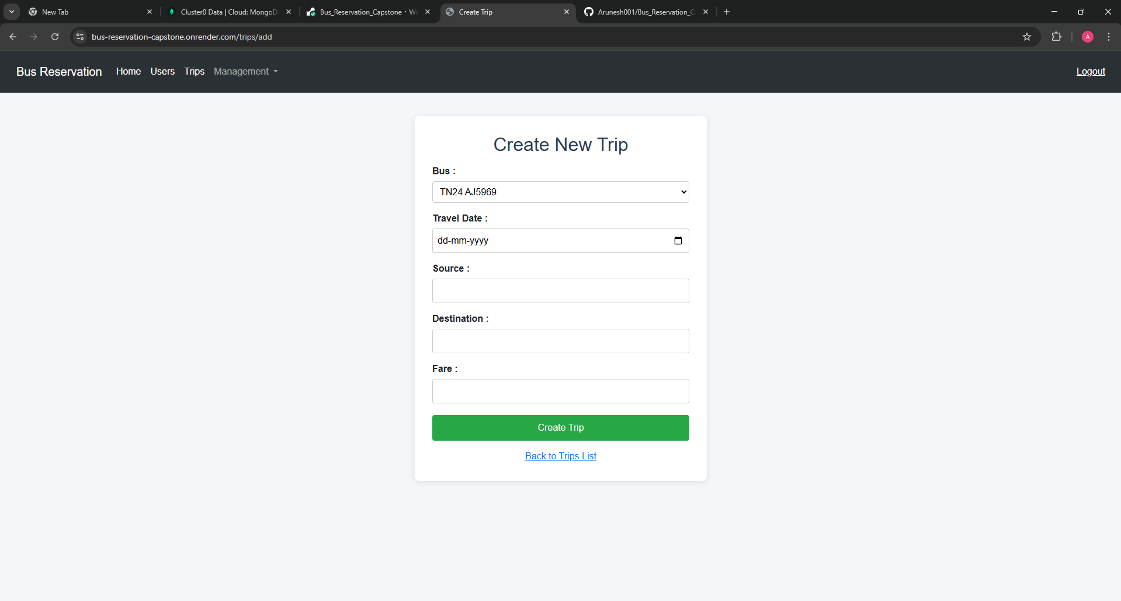

**Endpoint “/trips/list”:**

**https://bus-reservation-capstone.onrender.com/trips/list**

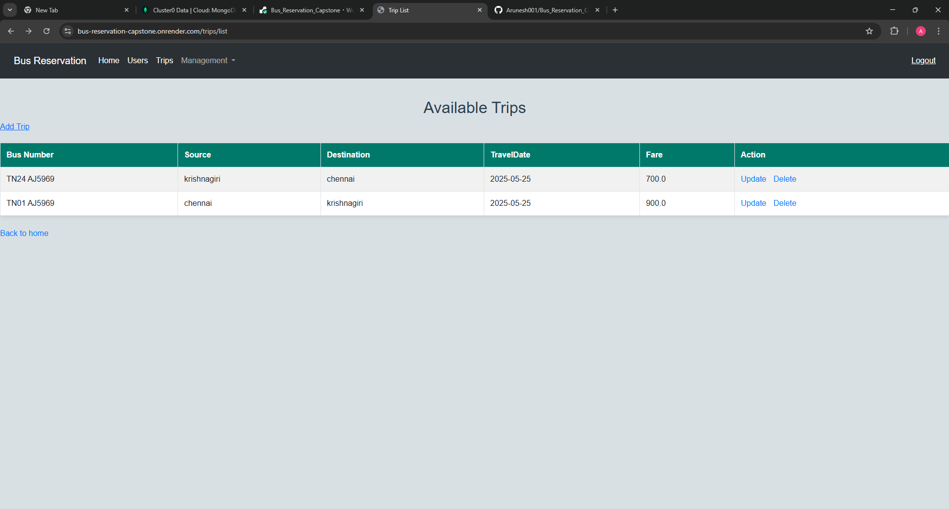

**Endpoint “/trips/update/{id}”:**

**https://bus-reservation-capstone.onrender.com/trips/update/6831eaf799357b66a59e8459**

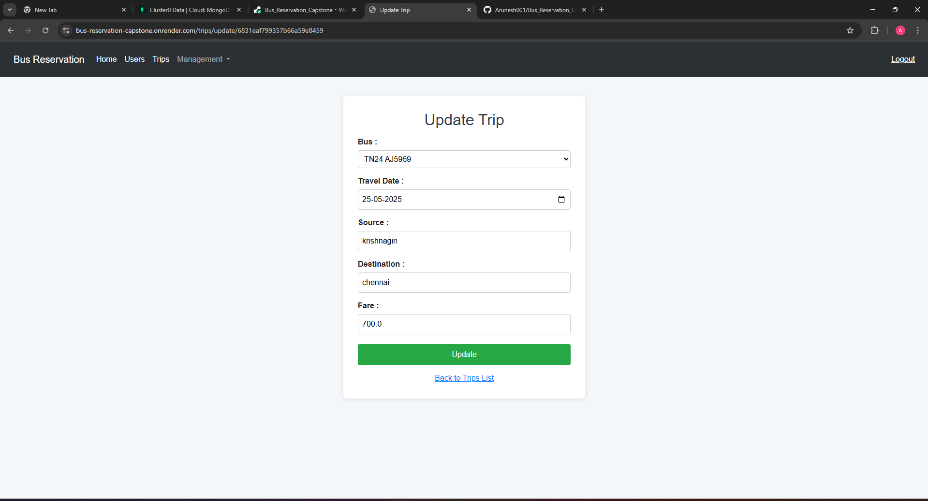

**Endpoint “/buses/add”:**

**https://bus-reservation-capstone.onrender.com/buses/add**

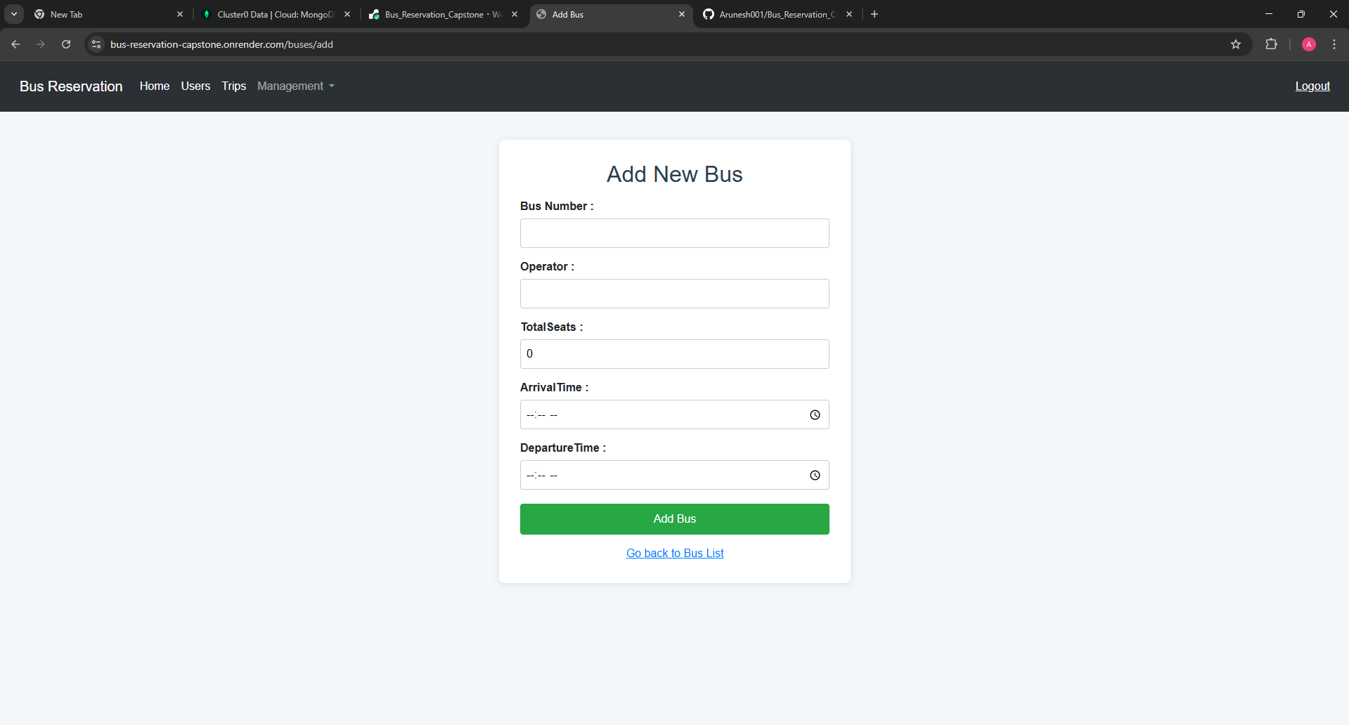

**Endpoint “/buses/list”:**

**https://bus-reservation-capstone.onrender.com/buses/list**

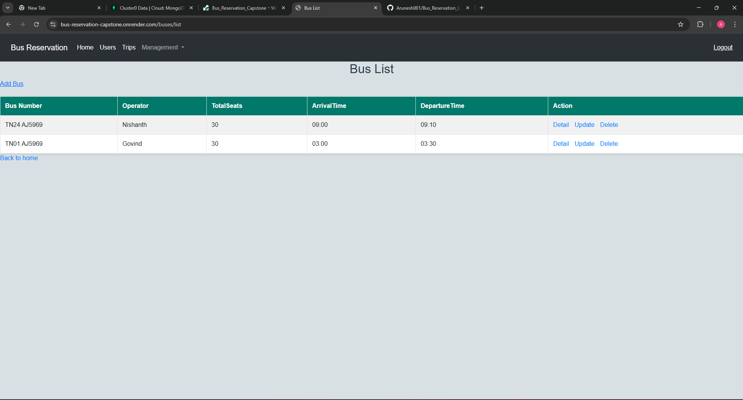

**Endpoint “/buses/detail/{id}”:**

**https://bus-reservation-capstone.onrender.com/buses/detail/6831eac499357b66a59e8458**

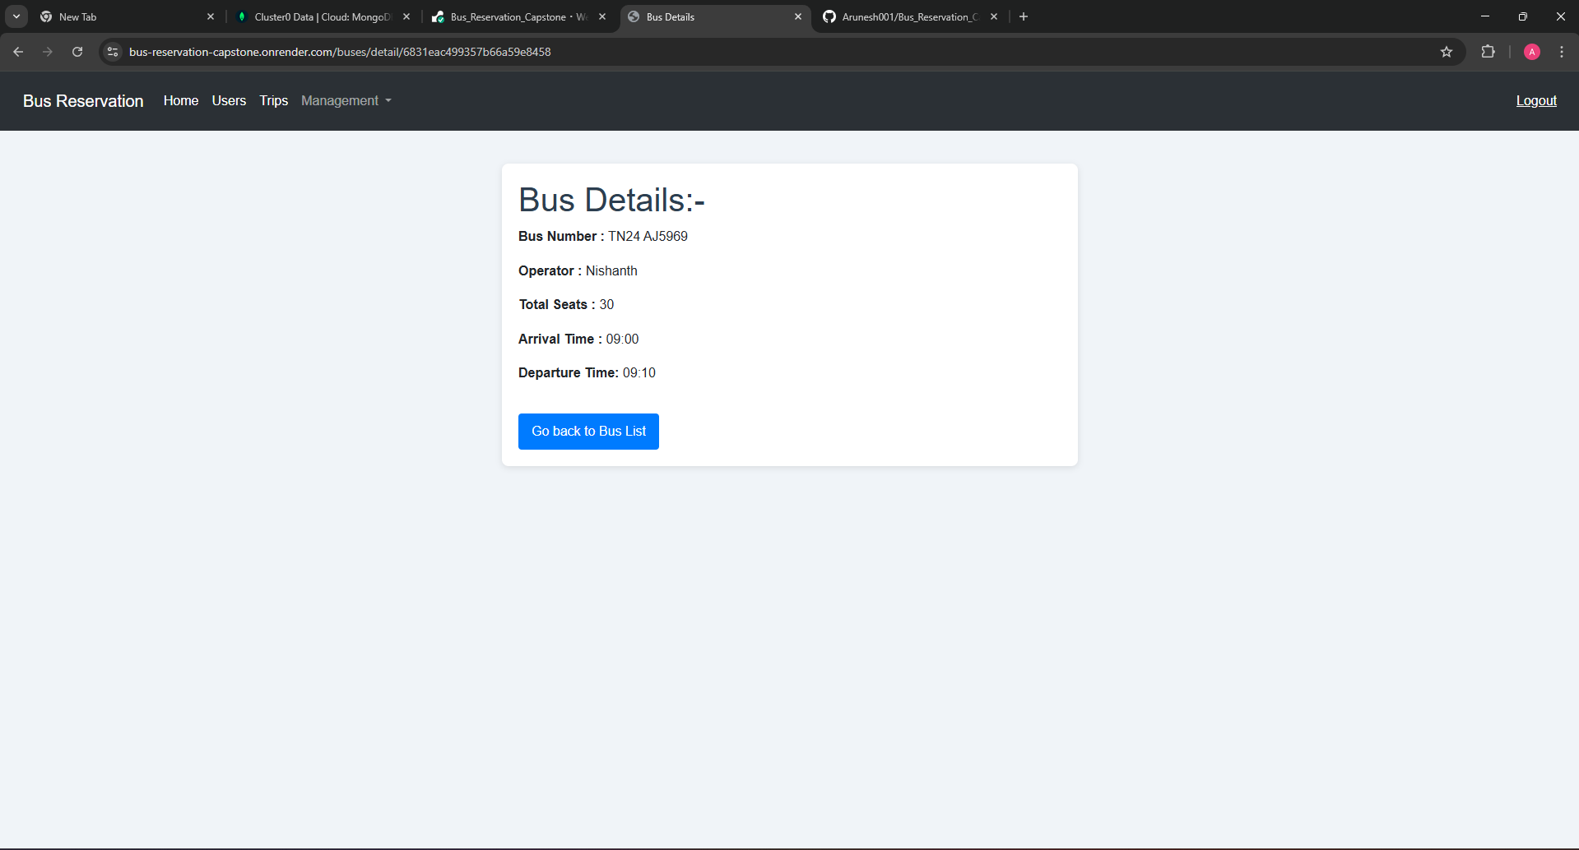

**Endpoint “/buses/update/{id}”:**

**https://bus-reservation-capstone.onrender.com/buses/update/6831eac499357b66a59e8458**

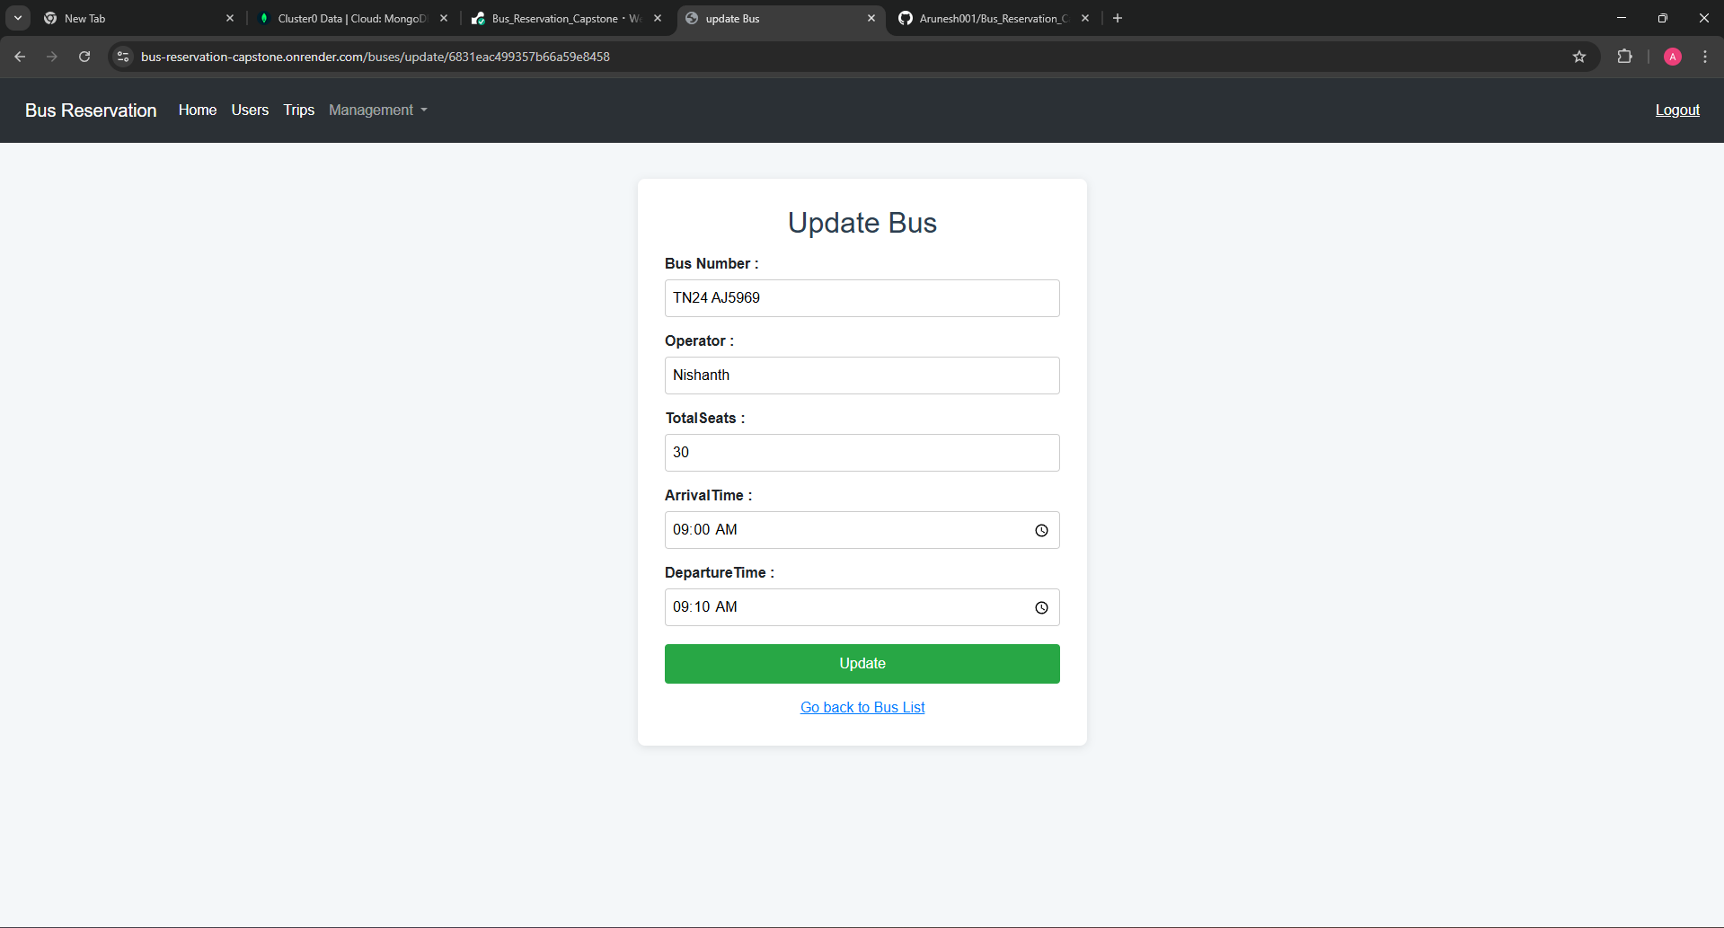

**Endpoint “/bookings/new”:**

**https://bus-reservation-capstone.onrender.com/bookings/new**

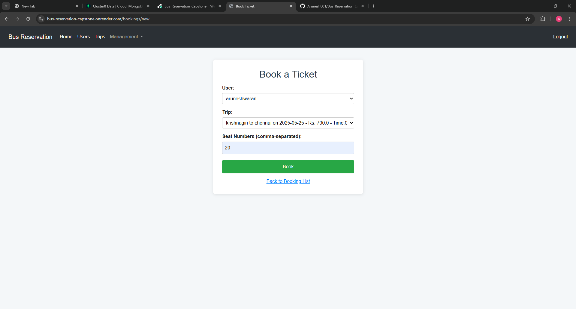

**Endpoint “/bookings/list”:**

**https://bus-reservation-capstone.onrender.com/bookings/list**

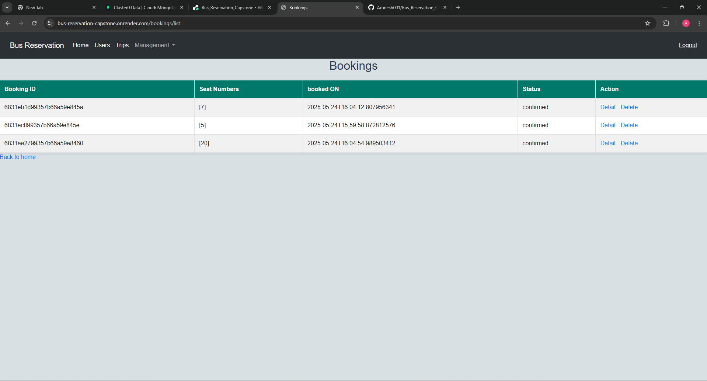

# How to Run

1. Clone the repo / open in IDE  
 2. Set up MongoDB (local or Atlas)  
 3. Run the application:  
 mvn spring-boot:run  
 4. Visit http://localhost:8080

# Future Improvements

- Email/SMS ticket confirmations  
 - Payment integration  
 - Seat selection  
 - PDF ticket generation  
 - Admin dashboard with charts

### 

### Conclusion

The Bus Reservation System project successfully streamlines the process of booking and managing bus trips using Spring Boot, MongoDB, and Thymeleaf. It ensures efficient handling of buses, trips, users, and bookings with a user-friendly interface and backend logic. The project meets its goal of creating a functional, scalable, and maintainable application for real-world bus reservation needs.

## Developer Info

- Author: Aruneshwaran

- Tools: IntelliJ, MongoDB Compass, Postman (for testing APIs)

- Application Live link : <https://bus-reservation-capstone.onrender.com>

**Note :**

Once you click the link it may take 1 or 2 mins to load the application so wait patiently.

Login info:-

admin:

username = admin

password = admin

user:

username = user

password = user